Padstow Heights Public School

2018

Anti-Bullying Plan
Aurelia Architecture

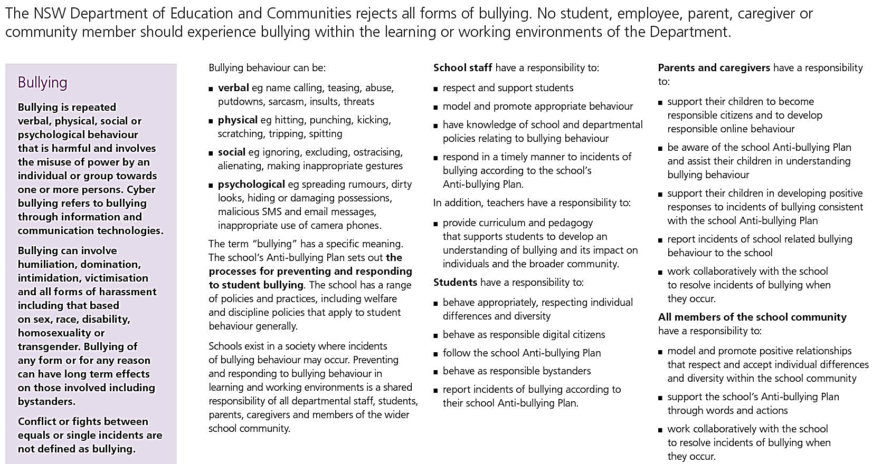

Bullying
Preventing and Responding to Student Bullying in Schools Policy (2011)
__________________________________________________________________________________________________________________________________________________________________________________________________________

Our School Anti-Bullying Plan
This plan outlines the processes for preventing and responding to student bullying in our school and reflects the Bullying: Preventing and Responding to Student Bullying in Schools Policy of the New South Wales Department of Education and Communities.
This plan is the result of consultations with staff, parents and students. Full implementation of the first teaching and learning cycle described will be complete by the end of Term 1, 2016. Lessons will be revised at the beginning of each term. The plan will be reviewed at the end of Term 3 each even year by a committee consisting of the student leaders, a teacher representative, a parent representative (as delegated by the Parents and Citizens group) and the principal. Any recommendations will be presented to the staff by Week 3 of Term 4 so changes can be made to the program in readiness for the beginning of the new school year.

Statement of purpose
Schools should provide a safe and supportive learning environment for all students. Students should feel a sense of belonging, participation and achievement. We must recognise that bullying occurs and that it needs to be dealt with swiftly and with due thought to procedural fairness. We aim to build a strong and supportive culture, so that bullying and anti-social behaviour is deemed by all to be unacceptable.

Protection

What is Bullying?
Bullying is the intentional, ongoing behaviour by an individual or group of individuals that causes upset, distress, hurt or an intense sense of fear.
Bullying is damaging to both the victim and perpetrator. It can be verbal, physical, psychological or cyber. It includes, but is not limited to:
- Verbal: name calling, teasing, abuse, ‘put downs’, insults or threats
- Physical: hitting, punching, kicking, scratching, tripping, spitting.
- Psychological: ignoring, excluding, daring, manipulating, making rude, cruel or crude gestures, racism, spreading rumours intentionally; dirty looks; hiding or damaging possessions; inappropriate notes, letters, phone messages, SMS misrepresentation, and emails, threats.

Rights and responsibilities:
All students and staff have the right to work in an environment free from violence and intimidation.
Right | Responsibility
To feel safe in the classroom | To ensure that you don’t make others feel unsafe in the classroom.
To feel safe in the playground | To ensure that you don’t make others feel unsafe in the playground.
To not feel bullied or picked on | To not bully or pick on others

Role of the students, staff and parents:
Teachers, students, parents, caregivers and members of the wider community have a responsibility to work together to address bullying.

Students should:
- Follow the school procedure when someone is bullying them (Stop, Walk, Talk)
- Follow the school procedure when they observe someone else being bullied. (Help others to follow Stop, Walk, Talk)
- Practise skills of self-discipline

Staff should:
- Follow school procedure when a student reports an incident of bullying but intervene immediately if a student is in danger of being hurt
- Use agreed language when responding
- Follow the school discipline code if the incident is proven
- Follow up all discipline actions to their completion which includes informing parents of incidents and actions taken

Parents should:
- Be aware of changes in your child’s behaviour and attitude at school
- Discuss any concerns with the class teacher as soon as possible
- Discuss with your child positive ways to handle the situation
- Support the school in its efforts against bullying
- Work with the school to ensure reasonable standards of behaviour from children
- Be role models for their children of non-bullying and respectful behaviour in their relationships with others

Prevention

Whole School Strategies
Following Positive Behaviour for Learning (PBL) guidelines and the Friendly School Plus program, the school has implemented a consistent approach to bullying which involves the use of common language by staff and students, a matrix of age-appropriate lesson plans which teach students the expected behaviours and processes to follow to deal with bullying, including cyber-bullying, and teacher training for a consistent response to complaints of bullying. Consequences for the perpetrators of bullying are embedded in the school discipline plan.
Parental involvement is encouraged and the school’s emphasis on developing quality relationships provides staff, students and parents with an environment that is positive and consistent.

Classroom Strategies
Anti-bullying lessons are presented in health, personal development & child protection lessons and also as the need arises in the form of discussions with individual children, small groups or whole school.
The teaching of social skills, including conflict resolution, is an integral part of lessons. Students are given opportunities to discuss and implement ideas for effective use of the playground, rules for games and procedures for resolving conflict in situations such as team games.
Class rules and expectations are negotiated with the teaching staff and students.
Computer Usage Agreement is in force. Students are aware that the Principal and staff have access to all student emails using their DoE address at any time.
The following is the framework of the anti-bullying plan which is taught to all students. It involves lessons on what to do if you are the victim, the bully or the bystander.
If students are feeling put-down, being verbally or physically abused, they are to:
Step1: Hold up their hand and assertively say STOP
Step 2: If the “bullying” does not stop students are to WALK away.
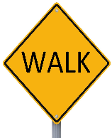
Step 3: If the ‘bullying’ still does not stop students are to TALK to a teacher.
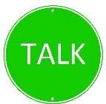
If any child is in danger or is being physically hurt, they are taught to go straight to a teacher.
If another student tells them to “STOP” or “WALKS AWAY”, this is a sign that the other student feels uncomfortable, put-down or bullied.
The students must:
- stop what they are doing
- take a deep breath and count to 3
- “get on with their day”, even if they disagree
Students are also encouraged to help a friend to walk away if they see that friend is uncomfortable, being put-down or bullied. The students are taught that good friends look after each other and it is not acceptable to just stand and watch when they see someone else is uncomfortable, being put-down or bullied.
This procedure is taught to each class through a series of lessons in Term 1. The lessons are revisited each semester or more often as the need arises.
Parents receive a brochure on enrolment and at the beginning of each even year, outlining the No Bullying Plan that operates in the school. Parents are also provided with the school discipline plan which shows the consequences for all inappropriate behaviours including bullying.

Response

Practices to deal with bullying behaviours
Instances of bullying are monitored through the school discipline system.
When a student reports an episode of bullying to the teacher, the teacher establishes that the student has followed the taught procedures for the situation and has been unable to stop the bullying. After investigating, the teacher will then record the incident, which may include the issuing of a “Time Out”. This information is then tracked by the Assistant Principal in charge of Student Welfare so that repeated cases involving the same student are able to be detected and followed up. The procedures for the follow up of all behaviour issues are described in the School Discipline Policy.
Where the bullying has been committed via cyber space then parents will be informed & computer privileges will be removed as per Computer Usage Agreement.
If the bullying behaviour has been identified, the perpetrator(s) will be interviewed by the class teacher as soon as possible after the reported incident has been investigated and substantiated.
- Interview with bullies. This is done alone, one by one, starting with the student seen as the group leader. This is a non-adversarial interview designed to emphasise the concern of the person who is being hurt or elicit some empathy and to come to some agreement as to what the person might do to help the victim. During the meeting the teacher (usually the Assistant principal) remains calm, empathetic, never angry or indignant and respect is shown for the bully as a person.
- Interview with the victim. This is done in a supportive manner and the aim is to explore ways in which the victim can behave to minimise the chances of the bullying being repeated. This will involve the victim being reminded of the school-wide anti-bullying strategies, and may include being shown assertive behaviour and ways to reduce behaviour which may be provoking the bullies.
- Follow-up with bullies and victims. It is essential that daily follow-up takes place. This involves asking the bullies individually how they have followed through what they agreed to do to help the victim, and asking the victim how they are progressing and whether or not there have been any further incidents. The follow-up is initially carried out daily, then tapered off if all is going well.
- If the bullying behaviour does not stop as a result of this intervention, then the usual sanctions of the school discipline policy will be implemented. There will be a need to keep working with the victim at this time to support them and make sure that they continue to problem-solve to try to make sure that there is not something else they can do to prevent the bullying from recurring.

- The principal is notified of all cases of bullying.
- With primary school children, many cases of bullying can be stopped quickly with minimal intervention. However, in any situations where teacher intervention is necessary on more than one occasion with the same student, then parents of all students involved will be notified so that we can work together to restore and improve relationships between the children. Regular updates will be provided to parents of the students involved.

Student Welfare
Any student who has been affected by, engaged in or witnessed bullying behaviour will have access to support, which may include:
- the school counsellor
- teacher mentoring,
- peer support structures
At all times student wellbeing is the first consideration. If at any time the principal is concerned for a student’s safety, contact will be made with the Child Wellbeing Unit and then, as recommended, with the Department of Community Services.
Serious incidents involving assaults, threats, intimidation or harassment may be reported to the police.

Complaints
Complaints about a policy, procedure or guidelines can be made to the principal or to the directorate or unit responsible for that policy, procedure or set of guidelines. If the complaint is about the principal, you may wish to contact the School Education Director at the Regional Office in Riverwood.

Additional Information
Police Youth Liaison Officer (YLO) and Police School Liaison Officer- Contact Bankstown Local Area Command 9783 2261
Kids Helpline: 1800 55 1800 www.kidshelp.com.au

Principal’s comment Lindy Bryant
Students attend school to participate in quality education that will help them to become self-directed, lifelong learners who can create a positive future for themselves and the wider community.
Any inappropriate behaviour that gets in the way of teaching and learning at the school and interferes with the wellbeing of students cannot be accepted. Students, teachers, parents, caregivers and members of the wider school community have a shared responsibility to create a safe and happy environment, free from all forms of bullying.

This plan was developed by
- Lindy Bryant Principal
- Joanne Fair Assistant Principal
- Lisa Dwyer Assistant Principal
- Joshua Godkin Assistant Principal
In consultation with
- Leanne Iverach (President) and the Padstow Heights Parents and Citizens Association
- Reviewed by staff on 29th January 2018 and P & C on 7th February

School contact information
Padstow Heights Public School
Chamberlain Rd
Padstow Heights 2211
Ph: 9773 9340 Fax: 9792 3961
Email: Padstowhts-p.school@det.nsw.edu.au
School Website: www.padstowhts-p.schools.nsw.edu.au

Reviewed February 2018

